

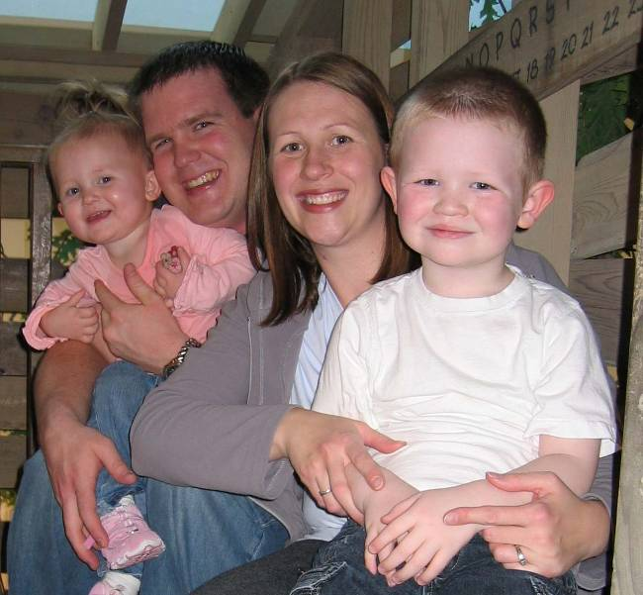
Nelson Family Newsletter

Happy holidays from

our family to yours!

St. Louis, MO - ‘It was a dark and stormy night’ were the words Paul wanted to use to begin his thesis, but that was rejected by his committee on multiple occasions.
This example should provide some clue as to the agonizing process for Paul to convince three professors to sign off on his thesis. Nevertheless, miracles do happen and Paul graduated with a M.S. degree in mech. engineering from BYU.
After Paul departed from the idealistic and corndog-filled academic world, he accepted employment with UGS, a software company, specializing in CAD/CAM/CAE/PDM/PLM/VIS software tool development and services. He quickly realized there are way too many acronyms used in industry. Paul enjoys his job, but is traveling more than expected which he does not take pleasure in.
If the travel continues to be overburdening, Paul has considered changing careers to be a professional snowman builder. National snowman building competitions are known to have purse prizes in the scores of dollars. Due to the seasonal nature of the work, we would probably have a summer home in the southern hemisphere to enjoy year-round winter.

Local thesis-defending Dad considers snow over dough ($)
Individual Highlights:

Paul’s News Page 1
Kate’s News Page 2
Grant’s News Page 2
Ella’s News Page 2

We thought this year we would try for a newspaper-type theme for our Christmas letter to share some of our best stories and pictures of 2005.
We will be reporting on topics covering academia, national employment trends, domestic affairs, youth violence, waste management facilities, human powered transportation, sports, art, current dance crazes, the classifieds, and even a sighting of the abominable snowman.

Nelson Family Highlights:

Paul graduated from BYU and began his first real job

Kate finally got that backyard she was longing for

Grant sang a solo in a church primary program

Ella has most of her teeth in and is walking everywhere
Celebrating Grant’s 4th Birthday on the 21 Dec. 2005 at the Magic House (A St. Louis Children’s Museum)
Nelson Family Christmas 2005

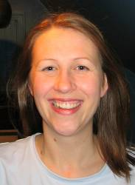
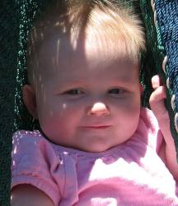

St. Louis, MO –
The 17 month old princess Ella enjoys her royal privileges, but at times takes things too far.
One of her highness’s most recent hobbies is to find objects she knows she shouldn’t have, show you she has it, and then run away laughing.
The princess has started a new dance craze of shaking her bootie to the music. She continues to gnaw on anything that is universally deemed inedible. She has sassy princess eyebrows that she flashes when she doesn’t get her way.
The princess was even caught placing graffiti on the wall with a sharpie marker (it came off with rubbing alcohol); she claimed it was art.
She has been caught wrestling with the boys and even tackling her own father, but over all she is just super cute and we couldn’t imagine a better princess.
St. Louis, MO –
We recently had the opportunity to interview Grant Matthew Nelson, a renowned not-so- international opera star.
Grant recently sang a solo in his church primary program in front of hundreds of people. He was only supposed to sing one verse and sit down, but he was in the zone, so he pulled the microphone back up and continued through the second verse.
We asked him a few questions and here is what he had to say:
Q: What do you like to do in St. Louis? A: Hide in the kitchen cupboards for hide and seek, build giant box forts with daddy, ride my big boy bike, and loves to cook cookies with mommy.
Q: Is it a competitive life, being an opera star? A: I like winning. I think we should just all take turns losing.
Q: You have accomplished so much, what’s next for you? A: I plan to start eating vegetables when I turn 10, I will continue to love my blue blanket (I just wish it was always cold), and I fully intent to stop sucking my finger when my first tooth falls out.
We came to learn that Grant is extremely smart and sometimes uses his smarts to ensure his designs are achieved.
St. Louis, MO – Kate Nelson, CEO of BURP (Behavioral Upheaval of Rotten Patterns), amazes us again with the introduction of her new book, ‘137 steps to keep your child from becoming a terrorist’.
Two volunteer children are mentioned throughout the lesson material; Ella, a super cute princess of 17 months, and Grant, a 4 year old, who at times is capable of exhibiting energy outputs approaching nuclear readings.
Kate has established a camp where rigorous training exercises take place to mold the minds of these young pupils. In the basement is a hammock hung from the rafters, a fort constructed of empty moving boxes, a donated ping pong table, a variety of sports balls, each pupil gets their own room, plus if they exhibit good behavior they receive reward time in a communal play room.
The program is so effective that when Ella is tired, she cuddles into Kate and joins Kate in singing twinkle, twinkle little star. Grant is now tame enough to read stories with Kate*.
Even Kate gets burned out, especially when cleaning the white vinyl floor of the facility, and so she highly recommends neck messages from her body guard Paul.
Kate has expanded the program to include a neighborhood playgroup and has even begun experimenting with a teenage youth Sunday school class.
*not recommended for all, Kate is a trained professional
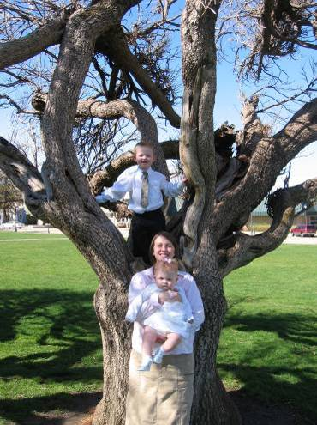

Energetic Mother tames fledgling terrorists with a smile

Opera star pays visit to St. Louis

Princess Ella of Nelson-Dom enjoys royal privileges

Page 2 of 3
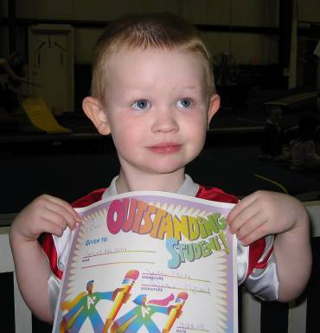
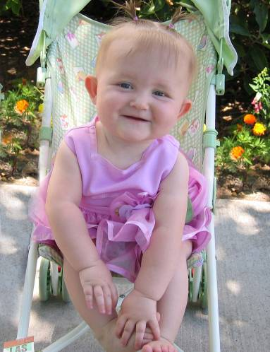
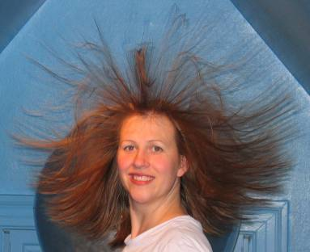
This time of year has a special feeling that makes us each want to be a little better and try a little harder.
We think that wonderful spirit of Christmas is just a small glimpse into the enabling power available to each of us through our Savior Jesus Christ.
We wish ya’ll the best for this holiday season and for the coming new year.

We guarantee delivery of this Christmas newsletter to all of those to whom we emailed it too.
Or, if you prefer to receive this Christmas newsletters by regular mail, just simply fill out the lower portion of this page, print, fold, and place this in your mailbox. A stamp has even been provided to keep your costs at a minimum.

Delivery of the Newsletter

Merry Christmas

Page 3 of 3

Nelson Family

4 Shady Bridge Ct.

O’Fallon, MO 63366

Home Phone:

(636) 240-7138

Paul’s Cell:

(314) 322-2654

E-Mail:
Paul – pfnelson@gmail.com
Kate – kate.e.nelson@gmail.com
Grant – grantMnelson@gmail.com
Ella – ellaDnelson@gmail.com





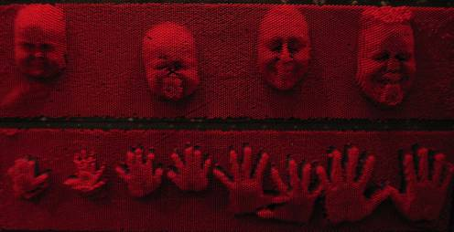

New Nelson ‘Home Sweet Home’
4 Shady Bridge Ct.



Your Name Here: ____________________________
Your Street Address Here: ______________________
Your City, State, Zip Code Here: _________________
Now place this in your mailbox and retrieve at will.

