H. ROICE NELSON, JR.
Finder / President
Walden 3-D, Inc. and
Dynamic Resources Corporation
P.O. Box 382
Barker, Texas 77413-0382
Telephone: 281.579.0172
Facsimile: 281.579.2141
Cell: 713.542.2207
rnelson@walden3d.com

SUMMARY OF EXPERIENCE
Roice is an experienced geoscientist in the international petroleum industry with proven success in using, creating, and building new tools and processes for the hydrocarbon exploration industry. He also formed a consulting company (W3D) and an exploration company (DRC) to utilize industry and proprietary tools and processes to explore for, develop, and produce hydrocarbons. As the initial founder of Landmark Graphics, Roice created a university program which placed advanced interactive interpretation systems in many universities worldwide to support research and teaching.

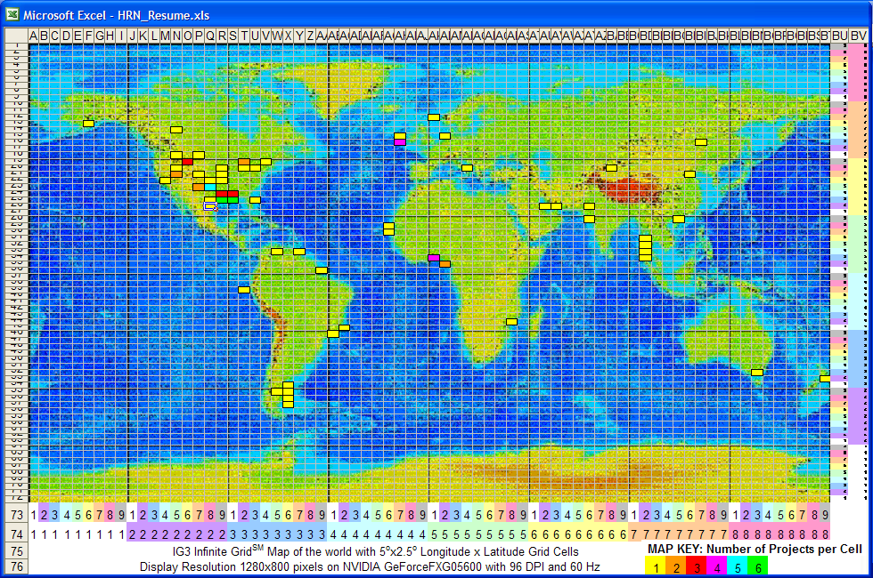

W3D Infinite GridSM Spatial Resume

CHRONOLOGY

Dynamic Resources Corporation Founder/President

January 2001 - Present
DRC was established to integrate advanced exploration technologies with a NetWork of proven professionals as synergistic multidisciplinary teams for exploration or production projects within specified areas and utilizing proprietary tools and processes. The goal is to develop exploration opportunities where investors putting up 3/3^{rds} of the investment retain 3/4^{ths} ownership, so DRC and the NetWork retain 1/4th ownership in discoveries. Focus is on Gulf Coast geopressure pods.

Walden 3-D, Inc. Founder/President

May 1990 - Present
W3D is a consulting company and new company incubator. Focus is on geotechnical consulting and mini-urban design. W3D started Walden Visualization Systems (the first virtual reality service company for the oil industry), vPatch (providing web-based project management), Advanced Structures Incorporated (building space-frame, fabric, and advanced enclosures), HyperMedia Corporation (the first commercialization of a UNIX hypertext browser), and others. W3D did major seismic interpretation projects in Nigeria, in the United States, through the Texas Bureau of Economic Geology in Venezuela, in India, and other places.

Geophysical Development Corporation (GDC) Vice President Interpretation

April 2004 – September 2007 – Business Development
Roice was charged with opening the market for GDC in China, and building an integrated interpretation business. Major processing and interpretation projects were completed for Ji Dong, Tarim, Da Qing, Xing Jiang, and Tuha Chinese Oilfields. As Product Manager for GDC’s TilesTM Studies in the Gulf of Mexico, his team built a new type of regional rock properties / AVO context study - designed to allow easy amplitude and AVO evaluation for a specific prospect. This includes introduction of d-TIPS (database Toolkit for Integrating Petrophysics and Seismic developed by Fred Hilterman), and SEG-Y geophysical rock property volumes created at regional scales, or to match the bins in a specific 3-D seismic survey.

Continuum Resources International Corporation Co-Founder

September 1997 - August 2000
Roice merged Walden Visualization Systems with Energy Innovations to create the first commercial petroleum industry visualization theaters. The team designed software to read from any databases or file with spatial information and to integrate the displays as a 3-D virtual reality experience. Continuum established simultaneous display and interaction capabilities, demonstrating a collaborative London England, Perth Australia, and Houston Texas connection.

The Global Basin Research Network Co-Founder

September 1992 - November 1994
Roice participated in Department of Energy study with Lamont-Doherty Earth Observatory of Columbia University, Cornell University, Louisiana State University, Woods Hole, Penn State, and other major universities on dynamic replenishment of the largest Pleistocene oil and gas field in the Gulf of Mexico. The GBRN consortium continued through 2005.

HyperMedia Corporation Co-Founder

January 1991 - Present
The HMC team designed, built, and produced a UNIX, X-Windows, Motif, Client-Server hypertext engine used for major projects in The United States, Saudi Arabia, and New Zealand, including development of a process model for running the ideal oil and gas company.

Landmark Graphics Corporation Co-Founder

November 1982 - September 1992
Roice designed the functionality of Landmark Graphics seismic interpretation software. The Landmark team created worldwide markets, with training courses and with technical support. As the only experienced end user at LGC, he participated in regional and detailed interpretation projects in The United States, Canada, China, Australia, Indonesia, and the North Sea with most of the major oil and gas exploration companies. He established Landmark's University Program, helping students and professors develop new technologies from Australia to Holland.

University of Houston's Allied Geophysical Laboratory (AGL) Co-Founder

University of Houston's Seismic Acoustics Laboratory (SAL) General Manager

January 1980 - November 1982
Roice managed the physical modeling facility at the SAL. He helped create and managed four new laboratories for studying vector processing, image processing, well logging tools, integration of all exploration activities, and wrote the book New Technologies in Exploration Geophysics.

Mobil Oil Corporation Geophysicist

July 1974 - January 1980
Roice worked as an interpretation and acquisition geophysicist. He participated in regional and detailed interpretation projects as well as equity re-determinations in the Far East, South America, Europe, Africa, and The United States. For over a year he co-managed four land seismic crews and trained new hires in seismic acquisition.

Amoco Corporation and Pan American Corporation Assistant Geophysicist

Summer 1973 & Summer 1970
Roice was a Summer Intern and Assistant Geophysicist in Denver. He worked on seismic acquisition and interpretation projects, including geological field work, doing noise tests for acquisition design, and setting up barge seismic acquisition on the Great Salt Lake.

EDUCATION
30+ years of industry experience.
Southern Methodist University (SMU) - 1981 MBA (Masters of Business Administration).
University of Utah - 1974 - B. S. Geophysics.

OTHER
- Published 181 technical papers since 1973, an index of which will be supplied upon request.
- Co-organized 8 SEG Research Workshops.
- Honorary Membership HGS (Houston Geophysical Society)
- Enterprise Award SEG (Society of Exploration Geophysicists)
- Active Member of AAPG, EAGE, GSH, HGS, SEG, and World Future Society

